Pavan Krishna

1MS17IS051

**Computer Graphics Assignment**

**Q> Explain the working of CRT with the help of neat diagram.**

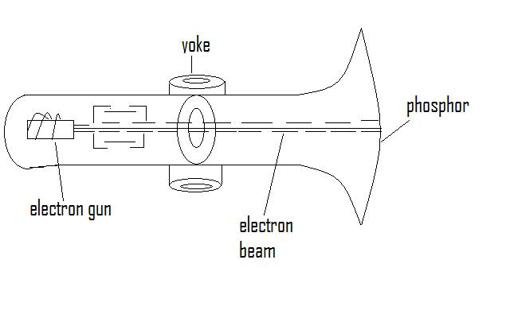**ANS>** The basic arrangement of CRT is as shown :-

At the narrow end the conical glass tube is sealed and an electron gun that’s emits high velocity focused beam of electrons is placed. At the other end the face of the CRT is more or less flat and is coated on the inside with phosphor,which glows yellowwhen electron beam strikes . The yoke or a system of electromagnetic coils is mounted on the outside of the tube , at the base of the neck.

The electron Gun:-

* It must be accurately focused so that it produces a sharp spot of light where it strikes the phosphor.
* It must have high velocity since , brightness depends on velocity.
* The electron flow should be controlled so that the intensity can be controlled.

Therefore, The electron gun contains a number of parts :-

* The electrons are generated by a cathode , heated by an electric filament , a cylindrical metal control grid surrounds the cathode and has a hole at one end for the electrons to escape. The potential of the control grid , will modify the rate of flow of electrons.
* A four ring structure is used consisting of 2 or more metal plates at different potentials.
* An accelerating structure consisting of 2 metal plates mounted perpendicular to the beam axis , these plates are maintained at high potential.

The deflection system :-

* A set of coils are used , one to control horizontal and one to control vertical deflection. This deflects the electron beams to different parts of the tube face when current passes through the coils.

The deflection should occur rapidly since speed of definition determines how much info can be displayed without flicker.

To achieve this rapid deflection large amplitude of currents are used.

Phosphorous :-

Chosen for their characteristics and persistence , high efficiency in terms of electric energy converted to light and resistance to burning under high prolonged excitation.

**Q> Explain raster scan and random scan display.**

**ANS> Raster Scan Method:-**

In raster scan system , the electron beam is swept across the screen , one row at a time from top to bottom . As the beam moves across each row , the beam intensity is turned on and off to create a pattern of illuminated spots. The picture definition is stored in a memory area called refresh buffer or frame buffer. These values are then retrieved from the refresh buffer and painted on the screen one row at a time.

Refreshing on raster scan display is carried out at the rate of 60-80 Hz. At the end of each scan line the electron beam returns to the left side of the screen to begin displaying the next scan line .This return to the left of the screen after reflecting each line row is called horizontal retrace of the electron beam. At the end of each frame , the electron beam returns to the top left corner of the screen to begin the next frame and this is called vertical retrace.

**Random scan method:-**

When operated as a random scan display unit,a CRT has the electron beam directed only to the parts of the screen where a picture is to be drawn. Random scan monitors , draw a picture one line at a time.

Picture definition is stored in a set of line drawing commands in an area of memory called refresh display file or refresh buffer.This has higher resolution.

It cannot display realistic shaded screens.

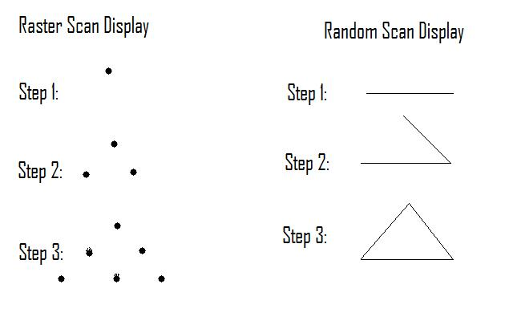

**Q> What is double buffering?**

**ANS>** A display that flickers or goes off for a second or two is not preferred . Therefore , an uninterrupted refresh is preferred even when part of the display file is processed and therefore , synchronization between processor that modifies and the processor that reads the display file is important . Consider a 3 segment display file as shown :-

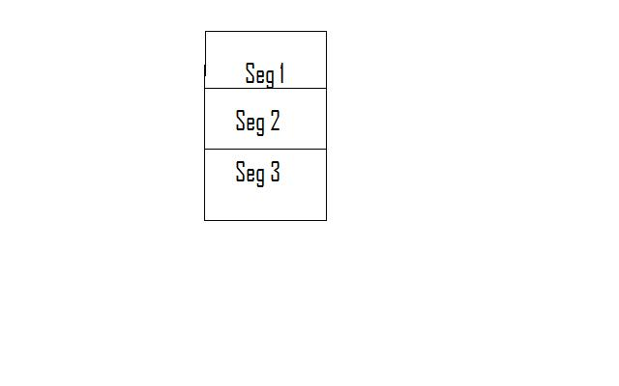

If segment 3 of the display file is being modified and is also being read by the display processor at the same time , the display processor may read part of the old code and this leads to corruption . To avoid this we can use double buffering. Here , the new code is constructed in an unused memory area , leaving the old code in a display file . When the new version is completely constructed, it replaces the old version of the code in the display file.

